Experiment 6 **STEPPER MOTOR USING 8051 USING KEIL AND PROTEUS**

**AIM:**

Write an assembly language program for Stepper Motor Using 8051 using Keil and Proteus

**SOFTWARE REQUIRED:**

* Keil software 5.
* Proteus 8 software.

**KEIL PROCEDURE:**

1. Open the software, Click on project and open new version project.

2. Create a new project file

3. Enter AT89C51

4. Click NO

5. Click [Ctrl +N] and Type the code

6. Open project and click Build target

7. Open Build target and open source file and ADD, CLOSE

8. Click build target

9. Next debug start and stop

10. Open peripherals and select port 2

11. Now run the program in Debug

12. Open project and click optional properties and in that give output as hex file.

13. Create hex file.

**PROTEUS PROCEDURE:**

* Open proteus by clicking run as administrator.
* Open new project and enter the file name.
* Click next, next, next and finish.
* Click P symbol and search keyword and place the required components

The components required are:

* AT89C51
* Motor Stepper
* ULN2803

* Connecting pin number 21 to 1 in ULN2803
* Likewise, connect pin 22,23 and 24 to the pin 2,3 and 4 in the ULN2803
* Connecting pin 18 from ULN2803 to one end of the stepper motor
* Connect pin 17,16 and 15 to each end of the stepper motor
* Connect the two ends of the stepper motor to each other parallel
* Now, right click and click place and then choose DC to select the Generator
* Connecting the generator to the Stepper motor
* Click on generator and change to 5volts
* Select the hex file
* Start the simulation process

**PROGRAM:**

ORG 0000H

UP: MOV P2,#09H

ACALL DELAY

MOV P2,#0CH

ACALL DELAY

MOV P2,#06H

ACALL DELAY

MOV P2,#03H

ACALL DELAY

SJMP UP

DELAY:MOV R4,#18

H1:MOV R3,#255

H2:DJNZ R3,H2

DJNZ R4,H1

RET

END

Circuit Diagram:

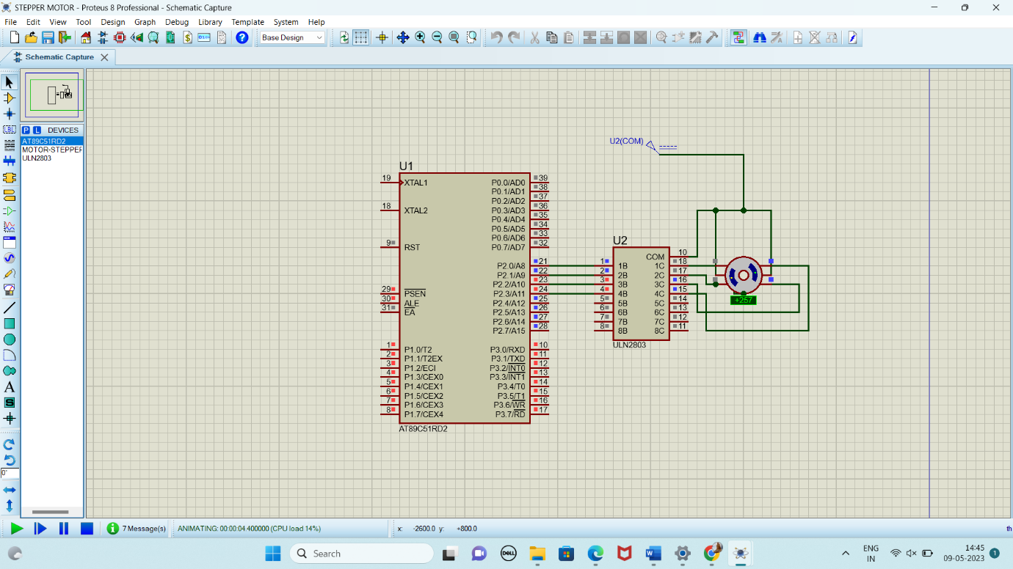

**RESULT:**

Thus the program has been successfully verified and executed.